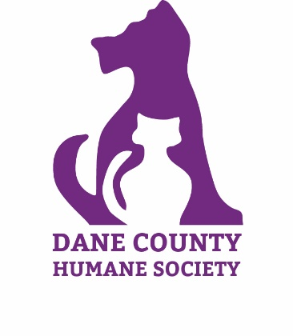
Dane County Humane Society

Animal Medical Services Internship Application

Dane County Humane Society is currently recruiting pre-vet and veterinary students who will help us support our mission “Helping People Help Animals” by participating in our Animal Medical Services Internship.
All potential interns must submit a completed application. If you support our mission
and are willing to put forth the time to be trained, we encourage you to complete this application.
APPLICATIONS DUE: February 15th, 2023

INTERN INFORMATION
Name: Click here to enter text.
E-mail address *: Click here to enter text.
*E-mail is our preferred method of contact. Our e-mail (calves@giveshelter.org) may be blocked by your filters; please check your junk e-mail folders if you have not received an e-mail from us confirming receipt of your application.

Permanent Address: Click here to enter text.
City: Click here to enter text.
State: Click here to enter text.
Zip: Click here to enter text.

Campus address: Click here to enter text.
City: Click here to enter text.
State: Click here to enter text.
Zip: Click here to enter text.
Phone (Home/Cell): Click here to enter text.

Emergency contact, phone number and relationship: Click here to enter text.

BACKGROUND INFORMATION
Have you volunteered or interned with Dane County Humane Society in the past? ☐Yes ☐No
Are there any medical conditions that may affect your ability to perform certain tasks? ☐Yes ☐ No
If yes, please explain: Click here to enter text.
Have you ever been convicted of a misdemeanor or felony? ☐Yes ☐ No
If yes, please explain: Click here to enter text.

ANIMAL MEDICAL EXPERIENCE
Education (Please note any classes you have completed which had an emphasis on animal medical care):
Click here to enter text.

Animal handling & training experience (Please note type of methods used):
Click here to enter text.

List any books, seminars, videos etc. that you have taken relating to animal care:
Click here to enter text.

Other medical related experience:
Click here to enter text.

Why would you like to intern with the Animal Medical Services at Dane County Humane Society? What specific skills or knowledge do you hope to gain in the course of this internship?
Click here to enter text.

Reference: Please list a business, education, or volunteer-related reference:
Name: Click here to enter text.
Contact info: Click here to enter text.

AVAILABILITY
Are you able to commit to Dane County Humane Society for the 12 week summer internship? ☐Yes ☐ No
If no, please explain:
Click here to enter text.
Do you have reliable transportation to Dane County Humane Society?* ☐ Yes ☐ No
*Unfortunately, the Main Shelter located at 5132 Voges Road in Madison is not easily accessible
by public transportation at this time.

Please check the days and that you prefer to intern:

 | Monday | Tuesday | Wednesday | Thursday | Friday
7:30 am to 5:30 pm | ☐ | ☐ |  | ☐ | ☐

INTERN APPLICATION AGREEMENT
I certify that the statements made in this internship application are true and have been given voluntarily. I understand that this information may be disclosed to any party with legal and proper interest, including for such purposes as criminal background checks, and I release the agency from any liability whatsoever for supplying such information. I also understand that I will not be paid for my services as an intern. In consideration of Dane County Humane Society accepting my application for participation in Dane County Humane Society programs, I agree to release and hold harmless Dane County Humane Society from and against any and all loss, damage, claims, liability, costs and expenses of any nature whatsoever, including without limitation, attorney's fees and disbursements, arising from or occasioned by my participation in Dane County Humane Society programs. I understand there are certain risks inherent in handling animals and I accept these risks. I agree that Dane County Humane Society may photograph my participation in this program and I hereby release any such photographs to Dane County Humane Society for use in its programs, publications and purpose.

Your Signature: Click here to enter text. Date: Click here to enter text.

Please submit applications to one of the following:
Email: calves@giveshelter.org
Mail: Dane County Humane Society
Attn: Celest Alves, CVT
5132 Voges Road Madison, Wisconsin 53718
Fax: (608) 838-0368

